- Wi-Fi Standards and Wireless Networking Assignment
1. Popular Wi-Fi Standards
Wi-Fi Standard | Maximum Speed | Frequency Band | Key Difference
802.11n (Wi-Fi 4) | Up to 600 Mbps | 2.4 GHz and 5 GHz | First standard to support both frequency bands.
802.11ac (Wi-Fi 5) | Up to 6.9 Gbps | 5 GHz only | Faster than 802.11n and uses only the 5 GHz band.
802.11ax (Wi-Fi 6) | Up to 9.6 Gbps | 2.4 GHz and 5 GHz (and 6 GHz for Wi-Fi 6E) | Higher speed and better performance with many connected devices.

2. Home Wi-Fi Network Diagram
Internet
|
Modem/ISP
|
(Wired Connection)
|
+-----------+
| Router |
+-----------+
)))))
Wi-Fi Signal
)))))
|
Smartphone
192.168.1.100
Network Parts
- Wired Part: Internet → Modem → Router
- Wireless Part: Router → Smartphone (Wi-Fi)
The router receives internet through a wired connection and sends it wirelessly to the smartphone.
3. Available Wi-Fi Networks
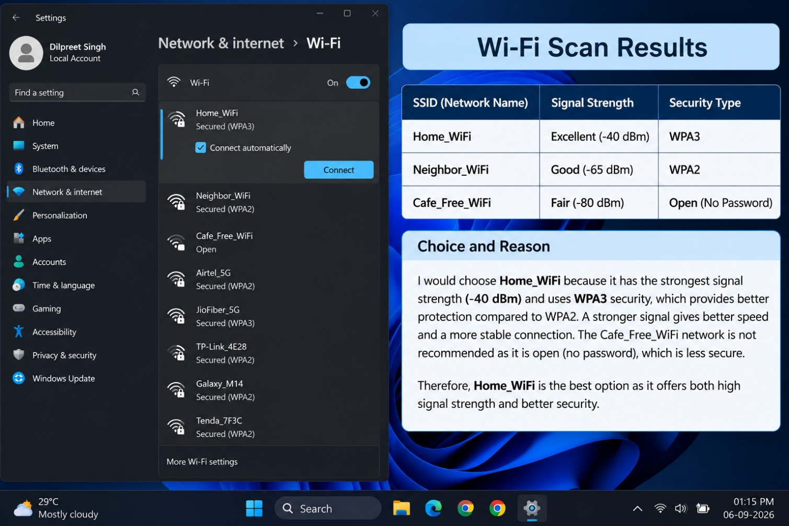
Sample Wi-Fi Scan Results
SSID (Network Name) | Signal Strength | Security Type
Home_WiFi | Excellent (-40 dBm) | WPA3
Neighbor_WiFi | Good (-65 dBm) | WPA2
Cafe_Free_WiFi | Fair (-80 dBm) | Open (No Password)
Which Network Would I Choose?
I would choose Home_WiFi because:
- It has the strongest signal strength.
- It uses WPA3, which is more secure than WPA2.
- It is password protected and safer than an open network.
Why Not the Others?
- Neighbor_WiFi: Good signal but not my network.
- Cafe_Free_WiFi: Weak signal and no security, making it less safe.
4. SSID Hiding
What is SSID Hiding?
SSID hiding means the Wi-Fi network name is not broadcast publicly. People scanning for Wi-Fi networks will not see the network name in the available network list.
Users must manually enter the network name (SSID) and password to connect.
Advantage of SSID Hiding
- Provides a small amount of privacy because the network name is not visible to everyone nearby.
Disadvantage of SSID Hiding
- It does not provide strong security because attackers can still detect hidden networks using special tools.
- It can make connecting devices more difficult because users must enter the network name manually.
Conclusion
Wi-Fi standards have improved over time, providing faster speeds and better performance. A home Wi-Fi network uses both wired and wireless connections to provide internet access. When choosing a Wi-Fi network, signal strength and security should both be considered. SSID hiding can improve privacy slightly, but it should not be relied upon as a security measure.

